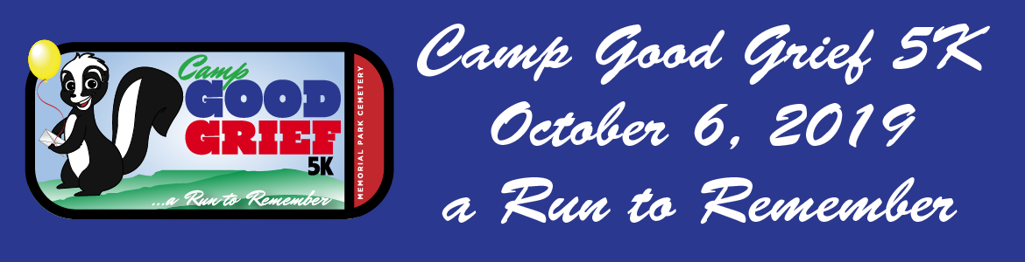
Sponsorship Opportunities
Presenting Sponsor $5000
This sponsorship includes logo inclusion on all media, shirts, race materials, race day signage and registration website. Website logo will be an active link to your company website. We will promote your sponsorship and company via our social media efforts and race day recognition. This sponsorship also includes 10 free race entries. Your company will have the opportunity to set up a tent at the race.

Double the Fun Sponsor $3000
Sponsor two campers! This sponsorship includes logo inclusion on race day signage and registration website. Website logo will be an active link to your company website. We will promote your sponsorship and company via our social media efforts and race day recognition. This sponsorship also includes 5 free race entries. Your company will have the opportunity to set up a tent at the race.

Send a Kid to Camp Sponsor $1500
Sponsor one camper! This sponsorship includes logo inclusion on race day signage and registration website. Website logo will be an active link to your company website. We will promote your sponsorship and company via our social media efforts and race day recognition. This sponsorship also includes 2 free race entries.

Yellow Balloon Sponsor $500
This sponsorship includes putting your logo race day signage and the website. This sponsorship includes 2 free race entries.

